H.T No
Regulations:
A20

Sreenidhi Institute of Science and Technology
(An Autonomous Institution)
Code No:8B729 Date: 10-June-2024 (FN)

B.Tech IV-Year I- Semester External Examination, June- 2024 (Supplementary)
ROBOTICS(ME)

Time: 3 Hours Max.Marks:70

Note: a) No additional answer sheets will be provided.
b) All sub-parts of a question must be answered at one place only, otherwise it will not be valued.
c) Missing data can be assumed suitably.

Bloom's Cognitive Levels of Learning (BCLL)

Remember | L1 | Apply | L3 | Evaluate | L5
Understand | L2 | Analyze | L4 | Create | L6

Part - A Max.Marks:20
Answer all QUESTIONS

 |  | BCLL | CO(s) | Marks
1 | Define the following terms a) Kinematics, b) workspace and c) trajectory | L1 | CO1 | [2M]
2 | Determine the transformation matrix T that represents a translation of ‘a’ units along X-axis, followed by rotation of β degrees about X-axis and followed by rotation of θ about Z-axis. | L2 | CO2 | [2M]
3 | Explain the Jacobian matrix and its significance | L2 | CO3 | [2M]
4 | What are Via points in the trajectory generation, explain their significance | L2 | CO4 | [2M]
5 | Draw the block diagram of a robot control system and explain | L3 | CO5 | [2M]
6 | Explain the following VAL commands a) MOVE b) MOVES c) APPRO d) CLOSE | L2 | CO6 | [2M]
7 | Discuss the factors considered in gripper selection | L3 | CO | [2M]
8 | Explain how the linear curve with parabolic blends is analyzed for a trajectory | L3 | CO | [2M]
9 | What is optical encoder? Explain its use | L2 | CO | [2M]
10 | Explain the following terms a) Link length, b) Link twist, c) Joint offset and d) Joint angle | L2 | CO | [2M]
Part – B Max.Marks:50
ANSWER ANY FIVE QUESTIONS. EACH QUESTION CARRIES 10 MARKS.

 |  |  | BCLL | CO(s) | Marks
11. | a) | Explain how the Robotics and Automation go hand in hand | L2 | CO1 | [5M]
 | b) | Define a Robot by various ways and furnish at least one definition which covers all the modern robots. | L3 | CO1 | [5M]
12. | a) | A vector P= 3 is first rotated by 90⁰ about X-axis, then by 90⁰ about Z-axis. Finally, it is translated by . Determine the new position vector of P. | L3 | CO2 | [5M]
 | b) | Calculate the forward kinematics for the given planar robotic manipulator  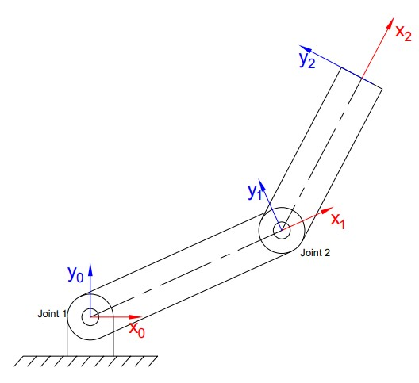 | L3 | CO2 | [5M]
13. | a) | Discuss Lagrange-Euler formulation for a robotic manipulator | L4 | CO3 | [5M]
 | b) | What is Linear position control? Explain briefly | L4 | CO3 | [5M]
14. | a) | Define Trajectory planning and discuss how it is done in case of a point-to-point robot. | L4 | CO4 | [5M]
 | b) | What are pseudo via points and their use? Explain their significance in the movement of a manipulator trajectory | L3 | CO4 | [5M]
15. | a) | With a block diagram, compare between open and closed loop systems with transfer equations | L5 | CO5 | [5M]
 | b) | Discuss the merits and demerits of the three basic types of drives used in robotic systems along with the criterion of selection | L4 | CO5 | [5M]
16. | a) | Discuss the generations of robot programming languages | L4 | CO6 | [5M]
 | b) | Briefly explain various sensors used in robotic manipulators and determine the essential features of sensors used in robotic manipulators | L4 | CO6 | [5M]
17. | a) | Explain the characteristics of robot cell design | L2 | CO1 | [4M]
 | b) | Explain the difference between forward and Inverse Kinematics of a robotic manipulator. | L2 | CO2 | [3M]
 | c) | What is force control law and position control law in manipulator dynamics | L4 | CO3 | [3M]
18. | a) | Explain the cubic polynomial fit via point for a smooth trajectory | L3 | CO4 | [4M]
 | b) | Explain the difference between manual teaching and lead through programming methods through examples | L3 | CO5 | [3M]
 | c) | Give a brief description about Robot Programming Languages | L2 | CO6 | [3M]
-- 00 -- 00 –

